Type this | To find this
bobby | Items containing bobby, BOBBY, BoBby, or any other combination of uppercase and lowercase letters. Instant Search is not case sensitive.
bobby moore | Items containing both bobby and moore, but not necessarily in that order.
bobby AND moore | Items containing both bobby and moore, but not necessarily in that order. Note that logical operators such as AND, NOT, and OR must be in uppercase letters.
bobby NOT moore | Items containing bobby, but not moore.
bobby OR moore | Items containing bobby, moore, or both.
"bobby moore" | Items containing the exact phrase bobby moore. Note the use of double quotes so that the search results match the exact phrase within the quotes.
from:"bobby moore" | Items sent from bobby moore. Note the use of double quotes so that the search results match the exact phrase within the quotes.
from:"bobby moore" about:”status report” | Items sent from bobby moore where status report appears in the subject line, body, and attachment contents. Note the use of double quotes so that the search results match the exact phrase within the quotes.
hasattachment:yes | Items that have attachments. You can also use hasattachment:true to get the same results.
subject:"bobby moore" | Items whose subject contains the phrase bobby moore.
subject:bobby moore | Items with bobby in the subject line and with moore anywhere else in the document.
cc:"bobby more" | Items in which the display name bobby moore is on the Cc line.
received:last week | Items that arrived last week. Note that if you run this query again a month from now you will obtain different results because it is a time relative query.
due:last week | Items that are flagged for follow up a due date.
hasflag:true | Items that are flagged for follow up.
received:”07/01/2019..07/15/2019” | To display all emails received in a specific date range
Searching in Microsoft Outlook:

From: https://support.office.com/en-us/article/Learn-to-narrow-your-search-criteria-for-better-searches-in-Outlook-d824d1e9-a255-4c8a-8553-276fb895a8da

How to create an email Rule in Microsoft Outlook:

- Click on the Home Tab and then the “Rules” section
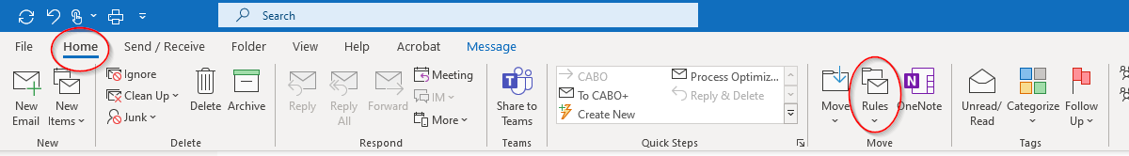

- Click “Create Rule”

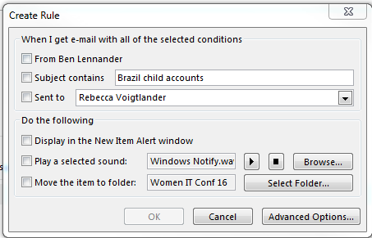

- Depending upon what you want to do you can select Advanced options
- You can create a rule that whenever you blind copy yourself, it goes into a specific folder

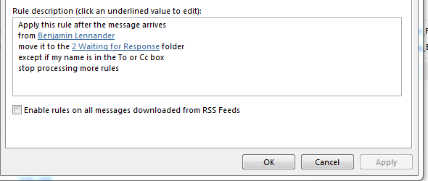

How to recall an email:
Open the Message – Click Actions then “Recall This Message” Choose the option you want then click Ok:

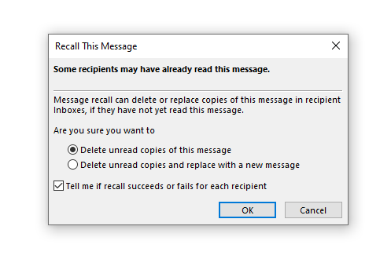

How to Create a Quick Step:

- Click on the Home Tab and then click on either “Create New” or the Manage Quicksteps button in bottom right corner of the Quick Steps area
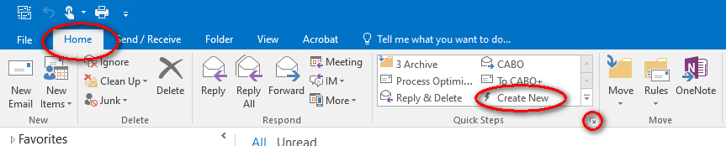

- Click on the New Button

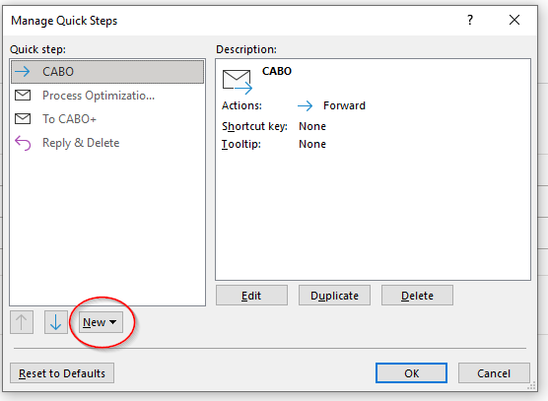

- Select “New Email to:”
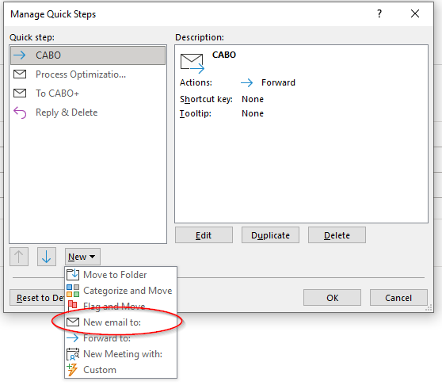

- Name the Quick Step, list the people you want to send the message to on a re-occurring basis then select Finish

